Florida Public Service Association  Certifies That  _________________________  From  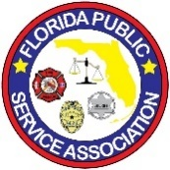  _________________________  Name of School  Is an Active Member | Florida Public Service Association  Certifies That  _________________________  From  _________________________  Name of School  Is an Active Member
Florida Public Service Association  Certifies That  _________________________  From  _________________________  Name of School  Is an Active Member | Florida Public Service Association  Certifies That  _________________________  From  _________________________  Name of School  Is an Active Member
Florida Public Service Association  Certifies That  _________________________  From  _________________________  Name of School  Is an Active Member | Florida Public Service Association  Certifies That  _________________________  From  _________________________  Name of School  Is an Active Member
Florida Public Service Association  Certifies That  _________________________  From  _________________________  Name of School  Is an Active Member | Florida Public Service Association  Certifies That  _________________________  From  _________________________  Name of School  Is an Active Member
Florida Public Service Association  Certifies That  _________________________  From  _________________________  Name of School  Is an Active Member | Florida Public Service Association  Certifies That  _________________________  From  _________________________  Name of School  Is an Active Member

