As the director of the Florida Public Service Association, Inc., let me welcome you to our student lead organization.

The FPSA is governed by two board of directors. The first is the student board that is comprised of a student state president, president elect, secretary, historian, parliamentarian, chaplain, sergeant at arms, and four regional vice-presidents. The second is the executive board of directors that is made up from chapter advisers and professional members of the FPSA and has a chairman, co-chairman, secretary, treasurer, and three other board members. The organization is run by the director who has the responsibility of daily operations.

Starting a chapter is easy. On our website is a brief outline of what is required in the handout, “Starting a Chapter.” If you are re-chartering with us just submit the renewal fee of $20. If you require an invoice, please let me know.

I have enclosed a list of all the competitions and a brief synopsis of the events. The full competition description along with the judges scoring rubric is available on our web page, www.myfpsa.us.

I encourage you to check out our web page at www.myfpsa.us. You will find more information about our organization and the career opportunities in the field of criminal justice, firefighting, and teaching. If you have any questions, please call me at 904-704-4222.

I look forward to receiving your request to become our newest or re-chartered organization.

Respectfully,
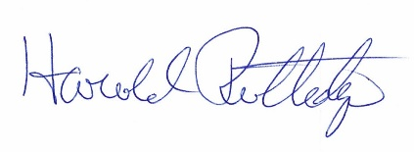
Harold Rutledge
State Director

